Step 2: Complete checklist
If it seems that the candidate site may meet the designation criteria, complete the designation checklist below (and provide all the relevant evidence). The checklist should be completed for each candidate site.
1 | General Information
1.1 | Name and address of site  Some sites have several names and all known names should be given
 | Amenity Area Stenor Close (D)
1.2 | Site location plan  The plan can be at any scale, but must show the location and boundaries of the site.  Please indicate the scale.
 | 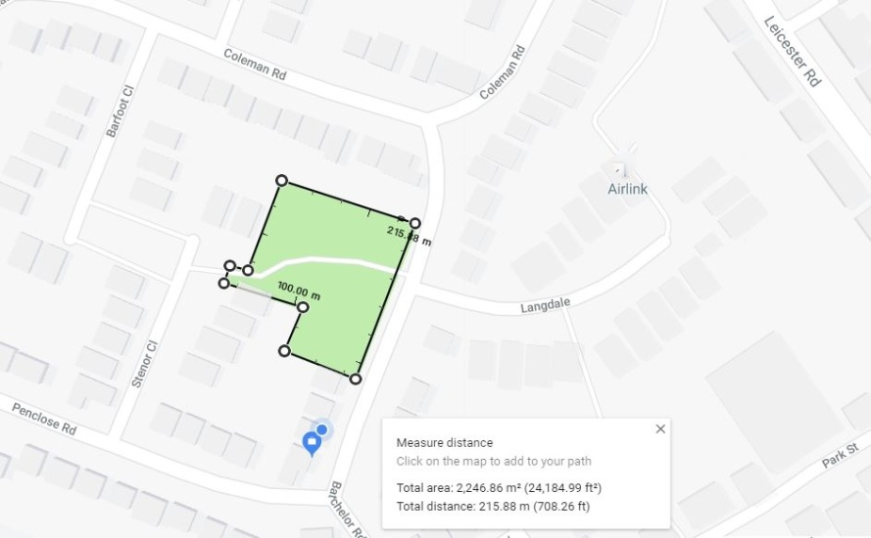
1.3 | Organisation or individual proposing site for designation  This will normally be a Town or Parish Council or a recognised community group
 | Fleckney Parish Council
1.4 | Ownership of site if known  Information on land ownership can be obtained from the Land Registry. Some land parcels are not registered however local people may know the owner.
 | Harborough District Council/ Leicestershire County Council (School)etc
1.5 | Is the owner of the site aware of the potential designation?
 | Yes
1.6 | Does the owner support the designation?  Sites may be designated as Local Green Spaces, even if there are objections from the site owners
 | Yes
1.7 | Photographs of site
 | Insert here or attach separately
1.8 | Community served by the potential Local Green Space  i.e. does the site serve the whole village/town or a particular geographic area or group of people?
 | The Whole comunity
2 | Planning History
2.1 | Is there currently a planning application for this site? If planning permission has been permitted could part of the overall site still be used as a Green Open Space?
 | No
2.2 | Is the site allocated for development in the Local Plan? If allocated, could part of the overall site still be used as a Green Open Space?
 | No
3 | Size, scale and “local nature” of proposed Local Green Space
3.1 | Area of proposed site  It is unlikely that a site of over 20ha (50 acres) would be considered suitable for designation.
 | 2247 sq M
3.2 | Is the site an “extensive tract of land”?  (Extensive tracts of land cannot be designated as Local Green Space)  e.g. how large is it in comparison to other fields; groups of fields; areas of land in the vicinity etc.? Does the site “feel” extensive or more local in scale?
 | No
3.3 | Is the proposed site “local in character”?  e.g. does the site feel as though it is part of the local area? And why? How does it connect physically, visually and socially to the local area? What is your evidence?
 | Fits in the area estabilished as part of the reqired green space when the estate was developed
4 | Need for Local Green Space
4.1 | Is there a need for a local green space in this location?  e.g. is there a shortage of accessible greenspace in the area? Is there a village needs survey or parish plan that provides evidence of that need. Further information – Natural England (Accessible Natural Greenspace Standard)
 | This is a small pocket of green space in a residential estate.
5 | Evidence to show that “the green space is in reasonably close proximity to the community it serves”
5.1 | How far is the site from the community it serves? Is the site within 2km of the local community?  Possible evidence – a map to show that distance
 | Map shows housing on the perimeter
5.2 | Are there any barriers to the local community accessing the site from their homes?  e.g. railway line; main road  Possible evidence – a map to show any potential barriers and how those can be overcome.
 | None
6 | Evidence to show that the green area is “demonstrably special to a local community”
6.1 | Evidence of support from Parish or Town Council  e.g. letter of support; Council minutes
 | Designated by Fleckney parish council and harborough District council
6.2 | Evidence of support from other local community groups or individuals.  e.g. letters of support; petitions; surveys etc.
6.3 | Evidence of support from community leaders  e.g. letters of support from Ward Members; County Councillors; MP etc.
6.4 | Evidence of support from other groups  e.g. letters of support from organisations such as Campaign to Protect Rural England; local amenity societies; local schools etc.
7 | Evidence to show that the green area “holds a particular local significance, for example because of its beauty,” (if applicable)
7.1 | Is this criteria relevant to this site?
 | YES / NO (probably all no)
7.2 | Describe why the community feels that the site has a particular local significance for its beauty.
 | N/A
7.3 | Site visibility  e.g. is it easy to see the site from a public place? Are there long-distance views of the site? Are there views of the site from any key locations?
 | n/a
7.4 | Is the site covered by any landscape or similar designations?  e.g. Area of Outstanding Natural Beauty; Conservation Area; Special Landscape Area  Further information –Natural England
 | No
7.5 | Is the site (or the type of site) specifically mentioned in any relevant landscape character assessments or similar documents?  Further information –Natural England
 | n/a
7.6 | Does the site contribute to the setting of a historic building or other special feature?
 | n/a
7.7 | Is the site highlighted in literature or art?  e.g. is the site mentioned in a well-known poem or shown in a famous painting?
 | n/a
8 | Evidence to show that the green area “holds a particular local significance for example because of its historic significance” (if applicable)
8.1 | Is this criteria relevant to this site?
 | NO
8.2 | Are there any historic buildings or remains on the site?  e.g. listed buildings; scheduled ancient monuments; registered parks and gardens; war memorials; other historic remains or structures.  Further information –English Heritage; local history society
 | No
8.3 | Are there any important historic landscape features on the site?  e.g. old hedgerows; ancient trees; historic ponds or historic garden features  Further information –English Heritage; local history society
 | Old Oak Tree
8.4 | Did the site play an important role in the historic development of the village or town?  e.g. the old site of the town railway station; the old garden for the manor house etc.
 | No
8.5 | Did any important historic events take place on the site?
 | No
8.6 | Do any historic rituals take place on the site?  e.g. well-dressing; maypole dancing etc.
 | No
9 | Evidence to show that the green area “holds a particular local significance, for example because of its recreational value (including as a playing field)”, (if applicable)
9.1 | Is this criteria relevant to this site?
 | Community gathering , children play area
9.2 | Is the site used for playing sport?  If so what sport? How long has it been used for sports provision? Is this sports provision free or is a club membership required?  Further information – Sport England
 | Adhock childrens sports
9.3 | Are the public able to physically access the site?  e.g. are there any public rights of way across the site? Or adjacent to the site? Has access been allowed on a discretionary basis? Is there public access to the whole site or only part? Is there good disabled access to the site? (A site can still be designated even if there is no public access.)
 | Yes
9.4 | Is the site used by the local community for informal recreation? And since when?  e.g. dog walking; sledging; ball games etc.
 | Yes to informal recreation since its its been established
10 | Evidence to show that the green area “holds a particular local significance, for example because of its tranquillity” (if applicable)
10.1 | Is this criteria relevant to this site?
 | NO
10.2 | Do you consider the site to be tranquil?  e.g. are there are any roads or busy areas close by?
 | No
10.3 | Is the site within a recognised tranquil area?  e.g. within the Campaign to Protect Rural England‟s tranquillity maps
 | No
11 | Evidence to show that the green area “holds a particular local significance, for example because of the richness of its wildlife”; (if applicable)
11.1 | Is this criteria relevant to this site ?
 | NO
11.2 | Is the site formally designated for its wildlife value?  e.g. as a site of special scientific interest; a key wildlife site etc Further information - Natural England
 | No
11.3 | Are any important habitats or species found on the site?  e.g. habitats and species listed in the UK priority habitats and species lists or in Biodiversity Action Plans or protected species or on the red/amber lists of birds of conservation concern.  Further information - Natural England; National Biodiversity Network; RSPB
 | No
11.4 | What other wildlife of interest has been found on the site?  Further information - Natural England; National Biodiversity Network
 | Wild birds nests
11.5 | Is the site part of a long term study of wildlife by members of the local community?  e.g. long-term monitoring of breeding birds.
 | No
12 | Evidence to show that the green area “holds a particular local significance, for any other reason”; (if applicable)
12.1 | Is this criteria relevant to this site?
 | NO
12.2 | What are the other reasons why the site has a particular local significance for the local community?
 | This is a modest pocket of much needed green in an overwhelming urbanized environment.

