Fleckney Neighbourhood Plan Review Questionnaire

Fleckney Parish Council is reviewing it Neighbourhood Plan and this survey will help determine the underpinning principles and overall direction of the review so it is important that we hear back from the residents of the village to help us make the right choices and decisions.

Neighbourhood planning is a process which has been designed to enable local communities to influence the planning and development of the areas in which they live and work. Neighbourhood planning enables people to shape the place in which they live their lives.

The survey will find out what people think and drawing on their skills and knowledge is an important part of the review process. A neighbourhood plan can’t prevent development but it can set out what type of development is appropriate and where it should be located.

Who can complete the questionnaire?

Any individual aged 18 or over is entitled to complete the questionnaire. This is an online questionnaire but a paper copy can be obtained from the Fleckney Library or Fleckney Sports Centre. You can also go to the Fleckney Neighbourhood Plan website www.fleckneynp.org.uk where you can download a printable copy.

If you require a large print version of the questionnaire or a translated copy if your first language is not English, please contact the Parish Council Tel: 0116 240 4589 or Email: fleckneynp@btconnect.com

What will we do with the information we get from the questionnaire?

Completed questionnaires will be analysed and the information gathered will enable us to formalise your views. We will also publish and share the findings from the survey at a future event and get your feedback on the issues and options identified. This will then help us in reviewing the Fleckney Neighbourhood Plan.

What about confidentiality?

The questionnaire is being used to help the Parish Council review its Neighbourhood Plan. The information you provide on the questionnaire is confidential. Your participation in this research, together with your individual responses to the questions will be kept strictly confidential, and no one will be identifiable in any published results. Your identity or personal details will not be disclosed.

The deadline date for the completion of the questionnaire is ??????????

Completed paper copies of the questionnaire can be handed in at the Sports Centre, Leicester Road or at the Library

WHY FLECKNEY

Q1 | What is your postcode?

Q2 | What do you enjoy/like about living in the Village? Tick all those that apply
 | A peaceful, quiet environment ..................... |  | A rural atmosphere .....................................
 | Easy access to the countryside (Hedgerows, trees, wildlife) ......................... |  | Strong sense of community .........................
 | Good facilities ............................................ |  | Easy access to other areas .........................
 | Anything else? Please let us know

ENVIRONMENT

Q3 | What new features do you think would be important for the Village to have?  Tick all those that apply
 | A Conservation Area .....................................................................................................................
 | More Allotments ............................................................................................................................
 | Wildlife Corridors (Areas connecting habitat and wildlife populations separated from human activities or structures such as roads, development) ......................................................................................
 | More Green/Open Spaces………………………………………………………………………………………
 | More Shops ..................................................................................................................................
 | Village Centre Highway Improvements…………………………………………………………………………
 | Anything else? Please let us know

Q4 | Which existing features would you like to see protected? Tick all those that apply
 | Open/green spaces inside the Village .......... |  | Preserved hedgerows .................................
 | Footpaths and opportunities for walking in and around the Parish ....................................... |  | Separation from surrounding settlements by fields/countryside ........................................
 | Millennium Wood (Mill Field Wood and other wooded areas) ........................................... |  | Ridge and Furrows fields .............................
 | Varied building styles throughout the Village |  | Community Buildings (e.g. Village Hall, Church)
 | The local pubs ............................................ |  | Primary School site .....................................
 | Leisure facilities .......................................... |  | Library ........................................................
 | Health Centre ............................................. |  | Heritage buildings .......................................
 | Anything else? Please let us know

Q5 | Have you been directly affected by flooding in the last 10 years?
 | Yes...............................................................................................................................................
 | No ................................................................................................................................................
 | If Yes, please provide details and location

Q6 | How often do you walk along public footpaths and bridle ways around the Village?
 | Daily .............................................................................................................................................
 | Weekly .........................................................................................................................................
 | Monthly .........................................................................................................................................
 | Never ...........................................................................................................................................

Q7 | Are there any particular footpaths or bridle ways around the Village that are problematic?
 | Yes...............................................................................................................................................
 | No ................................................................................................................................................
 | If Yes, please provide details and location

Q8 | Are there any new footpaths or cycle ways that you would like to see created within the village or in the local area?
 | Yes...............................................................................................................................................
 | No ................................................................................................................................................
 | If Yes, please indicate if a footpath or cycle way and the proposed route

Q9 | Do any of the following cause you concern within the Village? Tick one box in each row
 |  | Yes | No | No opinion
 | Crime
 | Anti-social behaviour
 | Noise
 | Dog fouling
 | Litter
 | Street lighting
 | Condition of verges
 | Removal of trees and hedges
 | Anything else? Please let us know

FACILITIES AND SERVICES

Q10 | How do you rate the following in terms of meeting the current and future needs of the Village? Tick one box in each row
 |  | Good | Adequate | Needs improvement | No opinion
 | Library
 | Sports Centre
 | Sports Facilities
 | Health Centre
 | Shops
 | Post Office
 | Dentist
 | Village Hall
 | Youth Club
 | Scout & Guide Facilities
 | Pre-School
 | Play Groups
 | Child Minding
 | Day Nursery
 | Primary School
 | Secondary School
 | Village Centre Highways
 | Village Centre Car Parking
 | Facilities for the Elderly
 | Anything else? Please let us know

Q11 | If you have Broadband Internet, how would you rate the following? Tick one box in each row
 |  | Excellent | Good | Poor | Bad | No opinion
 | The speed of your Broadband connection
 | The reliability of your Broadband service
 | Who is your current provider?

HOUSING
Q12 | Might you or a member of your family, be looking for alternative housing within the Village over the next 5 years
 | Yes ..............................................................................................................................................
 | No ................................................................................................................................................

Q13 | Please indicate below which type of property you or a family member would be looking for or what you believe is the right mix for the village. Tick all those that apply
 | Affordable home (2 bedrooms) .......................................................................................................
 | Family home (2 or more bedrooms) ................................................................................................
 | Executive home (4 or more bedrooms) ...........................................................................................
 | Bungalow (1 or 2 bedrooms) ..........................................................................................................
 | Adapted/easy access home ...........................................................................................................
 | Flat/apartment…………………………. .............................................................................................
 | Supported housing/retirement home ...............................................................................................
 | Residential nursing care ................................................................................................................
 | Other ............................................................................................................................................
 | If other, please describe

Q14 |  | Which of the following do you think are important features of any new housing development in the Village Tick all those that apply
 | Adequate off-street parking ..................................................................................................... |  | Yes | No
 | Affordable housing ...................................................................................................................
 | A mix of houses .......................................................................................................................
 | A mix of tenures (e.g. owner occupied, rented) ..........................................................................
 | Small gardens ........................................................................................................................
 | Large gardens ........................................................................................................................
 | Easy connection to footpaths and bridle ways ...........................................................................
 | Traffic calming measures within the development ......................................................................
 | New estates with connecting through roads ...............................................................................
 | New estates with single road access .........................................................................................
 | New estates don’t impact on the local highway network………………………………………………...
 | A mix of house designs sympathetic to the character of the Village .............................................
 | Eco friendly housing ...............................................................................................................
 | Protection of existing wildlife habitats .......................................................................................
 | Creation of new wildlife habitats ................................................................................................

Q15 | What level of building development do you feel would be appropriate to accommodate any new homes? Please tick those that apply
 | Small groups of up to 20 dwellings spread across a variety of sites ..................................................
 | Larger groups of up to 50 dwellings spread across suitable sites ......................................................
 | All required dwellings provided on a number of larger suitable sites ..................................................
 | Any other comments?

Q16 | In relation to further housing development, do any of the following give you concern? Tick one box in each row
 |  | Yes | No | No opinion
 | Pressure on the school places
 | Pressure on health services
 | Roads and traffic generally
 | Roads and traffic specifically in the village centre
 | Parking issues generally
 | Parking and traffic congestion at the primary school
 | Parking in the village centre
 | Surface drainage and flooding
 | Loss of green spaces
 | The Village losing its character
 | Anything else? Please let us know

Using the map shown, please tick the boxes below to indicate your ranking of potential sites
identified for future housing development where 1 is most appropriate and 5 the least appropriate

 |  | 1  Most appropriate | 2 | 3 | 4 | 5  Least appropriate
1 | 21/8055 Land to the west of Longgrey
2 | 21/8076 Land lying north-west of Kibworth Road
3 | 21/8066 Land south of Kilby Road
4 | 21/8087 Land north of Kilby Road
5 | 21/8088 Land to the east of Fleckney Meadows
6 | 21/8101 Land west of Leicester Road
7 | 21/8166 Land to the east of Fleckney Road
8 | 21/8174 Land off Burton Way
9 | 21/8205 Land south of Bird Cage Cottage, Arnesby Road
10 | 21/8216 Land south of Kilby Road (west)
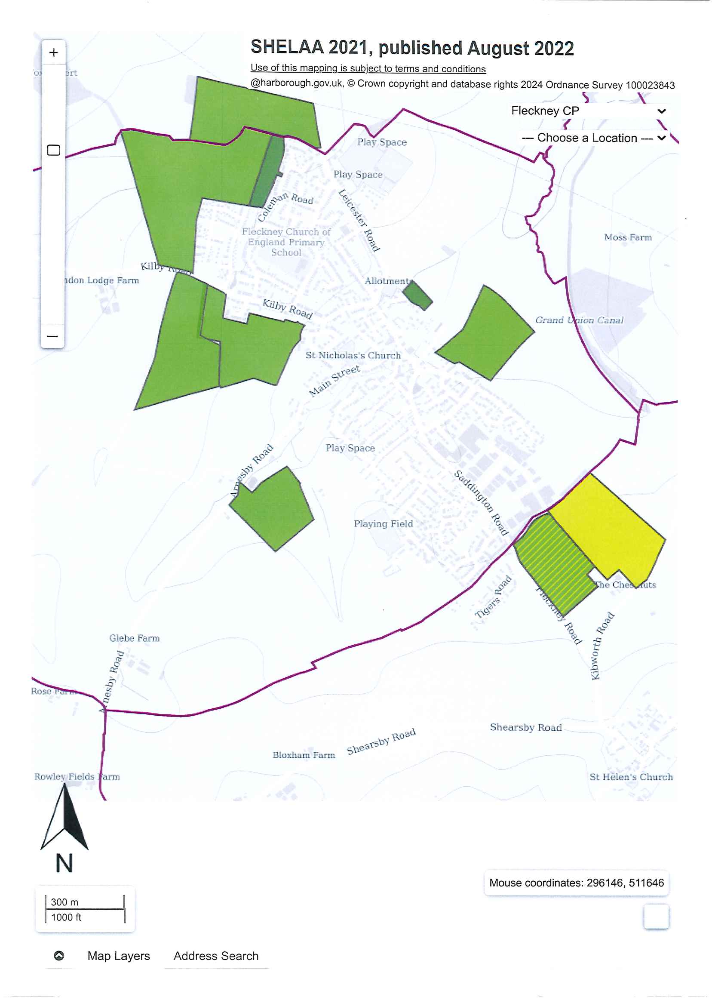
TRANSPORT

Q17 | Evidence from speed sensors indicate that there are speeding issues through the Village. Would you support any of the following speed control measures? Tick one box in each row
 |  | Yes | No | No opinion
 | Vehicle activated radar speed signs with speed display in the centre of the village
 | 20 mph speed limit throughout the Village with associated signs
 | Chicane/Priority gates
 | Anything else? Please let us know

Q18 | Please read through the following list of statements and tell us how much you agree or disagree with each one Tick one box on each row
 |  | Strongly agree | Agree | Neutral | Disagree | Strongly disagree
 | I am concerned about the condition and maintenance of pavements in Fleckney
 | I find the safety of pavements to be adequate within the centre of Fleckney
 | I find the width of the pavements to be adequate within the centre of Fleckney
 | I find the current car parking arrangements within the centre of Fleckney adequate
 | I am satisfied with the condition of the roads throughout Fleckney and surrounding area
 | I would be in favour a priority system in the centre of Fleckney to enable wider pavements on High Street and help alleviate congestion
 | I find the traffic congestion around the school at start and finish times unacceptable
 | Anything else? Please let us know

Q19 | Do you think any roads in the Village would benefit from being one-way?
 | Yes ..............................................................................................................................................
 | No ................................................................................................................................................
 | No Opinion ...................................................................................................................................
 | If 'Yes' Please give details of where

Q20 | Do you think alternative routes should be provided to reduce the traffic volume on existing roads through the village and in the centre of the village?
 | Yes ..............................................................................................................................................
 | No ................................................................................................................................................
 | No Opinion ...................................................................................................................................
 | Any other comments?

Q21 | Do you use the bus services serving the Village?
 | Yes ..............................................................................................................................................
 | No ................................................................................................................................................
 | If ‘Yes’, where do you normally travel to?

Q22 | How do you rate the bus services for the following? Tick one box in each row
 |  | Excellent | Good | Poor | Bad | No opinion
 | Routes
 | Timetables
 | Frequency at peak times

Q23 | If the Village was to be more cycle friendly, would you be more likely to cycle?
 | Yes ..............................................................................................................................................
 | No ................................................................................................................................................
 | No Opinion ...................................................................................................................................

BUSINESS AND THE LOCAL ECONOMY

Q24 | Do you work in the Village?
 | Yes ..............................................................................................................................................
 | No ................................................................................................................................................
 | Work from home…………………………………………………………………………………………………..
 | Do not work ..................................................................................................................................

Q25 | If your place of work is outside of the Village, which road do you use to leave/enter the village?
 | Leicester Road ....................................................................................................................................
 | Saddington Road .................................................................................................................................
 | Kilby Road ...........................................................................................................................................
 | Arnesby Road…………………………………………………………………………………………… ……

Q26 | What types of employment should be encouraged locally? Tick all those that apply
 | Light industrial and manufacturing ..................................................................................................
 | Shops-retail ..................................................................................................................................
 | Transport, storage and distribution .................................................................................................
 | Community services ......................................................................................................................
 | Financial and professional services ................................................................................................
 | Food and drink production .............................................................................................................
 | Agriculture related .........................................................................................................................
 | Pubs, restaurants and cafes ..........................................................................................................
 | Tourism, leisure and crafts .............................................................................................................
 | B&B/holiday accommodation .........................................................................................................
 | Other, please give details

Q27 | Should more land be allocated to encourage employment?
 | Yes ..............................................................................................................................................
 | No ................................................................................................................................................
 | No opinion ....................................................................................................................................

Q28 | Which types of sites should be allocated for employment use? Tick one box in each row
 |  | Yes | No | No opinion
 | Brownfield land (developed)
 | Greenfield land (undeveloped)
 | Conversion of existing buildings
 | Other, please give details

ANYTHING ELSE?

FINALLY,

We would appreciate it if you would please tell us a little about yourself by completing the ‘About You’ section on the next page. This information is optional, but it will allow us to demonstrate that we have gained the views of a cross section of the community when reviewing the Neighbourhood Plan.

All residents who submit a completed questionnaire by the deadline of ???????? and provide their contact details will also be entered into a ‘Prize Draw’ with a first prize of £100. The prize winner will be notified as soon as possible after the closing date.

Thank you for taking the time to complete this questionnaire.

ABOUT YOU

Q29 | What is your age?
 | 18-24 ...........................................................................................................................................
 | 25-44 ...........................................................................................................................................
 | 45-64 ...........................................................................................................................................
 | 65-74 ...........................................................................................................................................
 | 75 and over ..................................................................................................................................

Q30 | Which of the following best describes the household you live in?
 | One-person household ..................................................................................................................
 | A couple with dependent children ...................................................................................................
 | A couple without dependent children ..............................................................................................
 | Single parent household with dependent children ............................................................................
 | Single parent household without dependent children .......................................................................
 | Multi-person household.................................................................................................................

Prize Draw

The prize winner will be notified as soon as possible after the closing date.

Name

Address

